THE FOURTH SUNDAY OF ADVENT
Rite I Rite II
Prelude
Hymnal 66 Processional: “Come, thou long expected Jesus” Hymnal 66
Lighting of Advent Candle - Advent 4
Reader: Blessed are you, sovereign Lord, merciful and gentle; to you be praise and glory for ever. Your light has shone in our darkened world through the child-bearing of blessed Mary; grant that we who have seen your glory may daily be renewed in your image and prepared like her for the coming of your Son, who is the Lord and Savior of all.

People: Blessed be God for ever. Lord Jesus, light of the world, blessed is Gabriel, who brought good news; blessed is Mary, your mother and ours. Bless your Church preparing for Christmas; and bless us your children, who long for your coming. Amen
Reader: People of God: prepare! God, above all, maker of all, is one with us in Christ. Maranatha!
People: Come, Lord Jesus!
Reader: God, the mighty God, bends down in love to earth. Maranatha!
People: Come, Lord Jesus!
Reader: God with us, God beside us, comes soon to the world he has made. Maranatha!
People: Come, Lord Jesus!
Reader: We are God’s children; we seek the coming Christ. Maranatha!
People: Come, Lord Jesus!

THE LITURGY OF THE WORD
BCP 323 Opening Sentences BCP 355
S100 Trisagion S100
Insert Collect for the Day Insert
Insert The First Lesson: Micah 5:2-5a Insert
Insert Canticle 15: The Song of Mary (Luke 1:46-55) Insert
Insert The Second Lesson: Hebrews 10:5-10 Insert
Sequence: “O come, O come, Emmanuel” (vs. 1 ) Hymnal 56
Insert The Gospel: Luke 1:39-45 Insert
Sequence: “O come, O come, Emmanuel” (vs. 2) Hymnal 56
Sermon
BCP 326 The Nicene Creed BCP 358
BCP 328 Prayers of the People – Form IV BCP 388
BCP 330 Confession & Absolution BCP 360
The Peace
THE HOLY COMMUNION
Offertory Anthem
Robyn Long, oboist
Hymnal 380 The Presentation “The Doxology” (vs. 3) Hymnal 380
BCP 340 The Great Thanksgiving – Eucharistic Prayer A BCP 361
BCP 341 Sanctus and Benedictus S130
BCP 336 The Lord’s Prayer BCP 364
BCP 337 Fraction Anthem S164
BCP 337 Prayer of Humble Access

THE COMMUNION OF THE PEOPLE
All God’s people are welcome at the Lord’s table.

AIII 175 “They’ll Know We Are Christians By Our Love” AIII 175
AIII 184 “Praise Him, Praise Him” AIII 184
AIII 46 “God Is So Good” AIII 46

BCP 339 Post Communion Prayer (in unison) BCP 366
Hymnal 448 Recessional: “O love, how deep, how broad, how high” Hymnal 448
Dismissal
Postlude

NEXT WEEK’S LESSONS
Isaiah 61:10-62:3 * Psalm 147:13-21:
Galatians 3:23-25; 4:4-7 * John 1:1-18

Lay Ministers Today
8:00AM 10:30AM
Eucharist Ministers: Gerry King Katherine Smith
Lectors: Jimmy Striplin Laura Dissinger
Marilyn Burson Hervey Folsom
Intercessors: Jane Wood Cy Dempsey
Ushers: Carol Sok
Rick Dawson
Acolytes: Ben Storino, Addie Roberts and Alex Hancock
Altar Guild: Katherine Smith Augusta Andrews

Nativity Scene – The Children will set up the Nativity scene with Father Wally TODAY during the 10:30 service.

Grace Church Pageant Practice – TODAY, Sunday, 12/22 at 3:00 pm, AND Monday, 12/23 at 9:00 am in the Church.

Decorating the Church – The Altar Guild will be decorating the Church on Monday, December 23rd at 1:15 pm. All are welcome to come and help decorate the Church for Christmas Eve Services.

Peanut Butter Sunday – The last Sunday of each month is designated, Peanut Butter Sunday. Please place donations in the basket at the back of the church or in Tyler Hall. All donations will be distributed on Beans & Rice Saturday.

Wednesday Night Service. - There will be no Wednesday Night service this week. Please join us on January 8th when we resume back to normal schedule.

Cookies & Punch – Join us for cookies and punch in Tyler Hall on Christmas Eve immediately following the 4:00 pm worship service. Please bring a ½ dozen cookies or another treat to share.

Church Office Closed – The Church offices will be closed From Tuesday, December 24th until Monday January 6th, 2025. For office needs, contact Keli Wigley at 256-591-0073.

GRACE EPISCOPAL CHURCH
The Rt. Rev. Dr. Glenda Curry, Bishop; The Rt. Rev. Brian N. Prior, Assisting Bishop
The Rev. Wally LaLonde, Rector 575-202-8594
The Rev. Kathy LaLonde, Assisting
The Rev. Dr. David Whetstone, Deacon
Lisa Davis, Sr. Warden 256-239-4577 Christina Dorn, Dir. Christian Formation & Comm.
Mike Phillips Jr. Warden 256-239-0763 Keli Wigley, Office Manager
Steve Simmons, Music Director Faith Dorn, Youth Director
Gena Vinyard, Organist Tony Woodard, Sexton
Lisa Davis, Pianist

SUNDAY WEDNESDAY THURSDAY
Holy Eucharist Rite I 8:00 am Casual Worship 5:30 pm Centering Prayer 9:00am
Breakfast 9:00 am Book Study 10:00 – 11:00 am
Sunday School 9:30 am (meet in the Parlor)
Holy Eucharist Rite II 10:30 am Healing Service 11: 00 am

December 22, 2024

8:00AM & 10:30AM

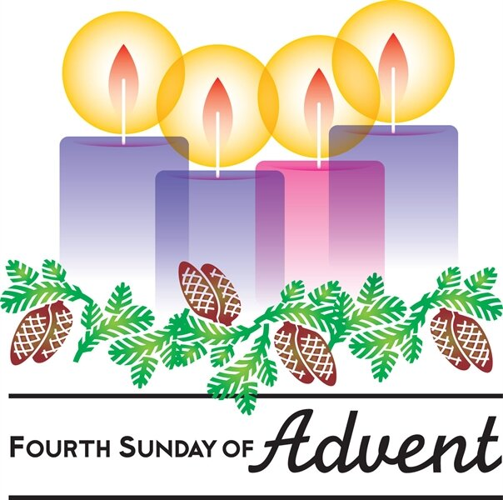

1000 Leighton Avenue at Tenth Street
Anniston, Alabama
Phone: 256-236-4457
www.graceanniston.org

“Growing together in the likeness of Christ”

