TWENTY SIXTH SUNDAY AFTER PENTECOST

Rite I Rite II
Prelude
Hymnal 388 Processional: “O worship the King, all glorious above!” Hymnal 388

THE LITURGY OF THE WORD
BCP 323 Opening Sentences BCP 355
BCP 324 Gloria S280
Insert Collect for the Day Insert
Insert The First Lesson: 1 Samuel 1:4-20 Insert
Insert Canticle: The Song of Hannah (1 Samuel 2:1-10) Insert
Insert The Second Lesson: Hebrews 10:11-14, [15-18] 19-25 Insert AIII 89 Sequence: “Jesus, Name Above All Names” (sing twice) AIII 89
Insert The Gospel: Mark 13:1-8 Insert
AIII 89 Sequence: “Jesus, Name Above All Names” (sing once) AIII 89
Sermon
BCP 326 The Nicene Creed BCP 358
BCP 328 Prayers of the People – Form VI BCP 392
BCP 330 Confession & Absolution BCP 393
The Peace

THE HOLY COMMUNION

Offertory Anthem
Hymnal 380 The Presentation “The Doxology” (vs. 3) Hymnal 380
BCP 340 The Great Thanksgiving – Eucharistic Prayer B BCP 367
BCP 341 Sanctus and Benedictus S124
BCP 336 The Lord’s Prayer BCP 364
BCP 337 Fraction Anthem S161
BCP 337 Prayer of Humble Access

THE COMMUNION OF THE PEOPLE
All God’s people are welcome at the Lord’s table.

AIII 138 “Sanctuary” AIII 138
AIII 50 “Great Is Thy Faithfulness” AIII 50
AIII 93 “In Christ Alone” AIII 93

BCP 339 Post Communion Prayer (in unison) BCP 365
Hymnal 665 Recessional: “All my hope on God is founded” Hymnal 665
Dismissal
Postlude

The flowers on the altar are given to the glory of God in celebration of Ed and Rita Bailey’s 57th Wedding Anniversary.

Last week’s Attendance:
8:00 am = 17
10:30 am = 64

NEXT WEEK’S LESSONS
2 Samuel 23:1-7 * Psalm 132:1-13, [14-19]
Revelation 1:4b-8 * John 18:33-37

Lay Ministers Today

8:00AM 10:30AM
Eucharist Ministers: Katherine Smith Donna Houston
Lectors: Glenda Barker Jane Wood
Perry Reynolds Betty Yarbrough
Intercessors: Jimmy Striplin Jill Pike
Ushers: Bob Folsom
Cy Dempsey
Acolytes: Hayes Farrell, Luke Farrell, Addie Roberts and
Jonas Storino
Altar Guild: Jane Wood Lisa Davis
CONNECT WITH GRACE

As you silence your phone for worship, we invite you to check in on social media.
Take a photo to share online or tweet a line from a prayer, a hymn, or the sermon.
We welcome and encourage you to use social media at Grace because we have Good News to share!

ECW Luncheon – Please join us tomorrow, Monday November 18th at 12:00/noon-1:00 pm. The cost is $5.00. Our speakers this month are Father Wally, Rev. Kathy and Braelyn Edwards. They will be discussing their August 2024 trip to Uganda and The Mustard Seeds Babies Home.

Angel Tree Christmas Outreach -We have been asked to purchase gifts for 11–17-year-old boys and girls. All details, gift suggestions, and a sign-up sheet are on the bulletin board in front of King Parlor. Questions? Call or text Faith Dorn. At 835-450-4400

ECW Warm Clothing Drive – During the month of November, the ECW will host a Warm Clothing Drive. They will be collecting warm clothing for women, men, children and infants. Please bring you items to Tyler Hall. Large boxes are provided and labeled. These items will be put out on the round tables in Tyler Hall on Friday, December 6th for distributions on Saturday, December 7th during Beans & Rice, from 8:30 am – 10:00 am.
.
Socks For North Carolina – St. Peter’s Episcopal Church in Talladega is collecting supplies for hurricane victims in North Carolina and is reaching out to sister churches in the Cheaha Convocation for help. St. Peter’s is working with St. James Episcopal in Black Mountain, NC., to deliver supplies to two (2) remote small towns that are receiving minimal assistance. They have asked the parishioners of Grace to consider donating new socks (all sizes). If you would like to help, socks may be left in the Foothills staging room.

GRACE EPISCOPAL CHURCH
The Rt. Rev. Dr. Glenda Curry, Bishop; The Rt. Rev. Brian N. Prior, Assisting Bishop
The Rev. Wally LaLonde, Rector 575-202-8594
The Rev. Kathy LaLonde
The Rev. Dr. David Whetstone, Deacon
Lisa Davis, Sr. Warden 256-239-4577 Christina Dorn, Dir. Christian Formation & Comm.
Mike Phillips 256-239-0763 Keli Wigley, Office Manager
Steve Simmons, Music Director Faith Dorn, Youth Director
Gena Vinyard, Organist Tony Woodard, Sexton
Lisa Davis, Pianist Sharon Ball, Housekeeper

SUNDAY Wednesday THURSDAY
Holy Eucharist 8:00am Casual Worship 5:30 pm Centering Prayer 9:00 am
Breakfast 9:00am Book Study 10:00 am -11:00am
Sunday School 9:30 am Healing Service 11:30 am
Holy Eucharist 10:30 am

November 17, 2024

8:00AM & 10:30AM

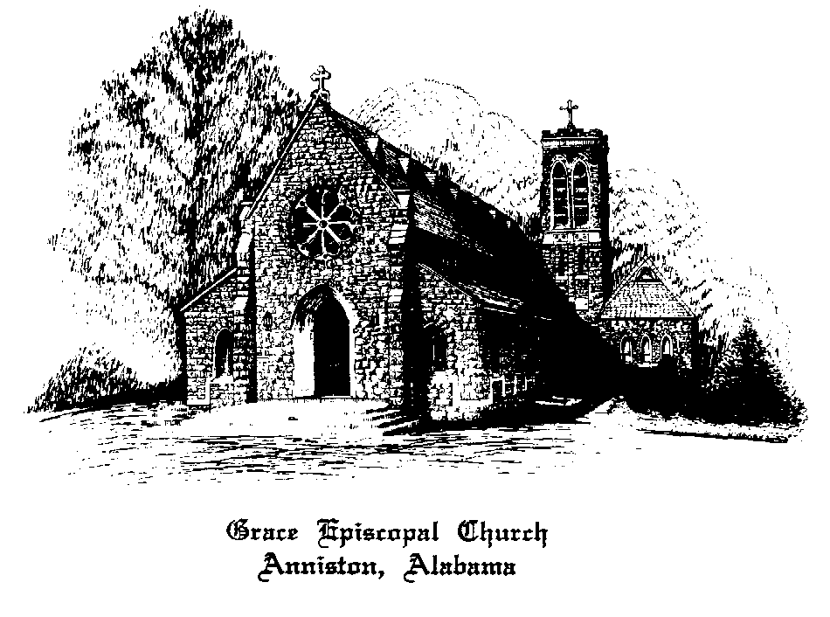

1000 Leighton Avenue at Tenth Street
Anniston, Alabama
Phone: 256-236-4457
www.graceanniston.org

“Growing together in the likeness of Christ”

