THE FIRST SUNDAY OF ADVENT

Rite I Rite II
Prelude
Lighting of Advent Candle - Advent 1

Hymnal 57 Processional: “Lo! He comes with clouds descending” Hymnal 57

Reader: Blessed are you, Sovereign Lord, God of our ancestors, to you be praise and glory forever! You called the patriarchs to live by the light of faith and to journey in the hope of your promised fulfillment. May we be obedient to your call and be ready and watchful to receive your Christ, a lamp to our feet and a light to our path; for you are our light and our salvation.
People: Lord Jesus, Light of the world, born in David's city of Bethlehem, born like him to be a king: Be born in our hearts this Christmastide, be king of our lives today. Amen
Reader: People of God: Wake! The day is coming soon when you see God face to face. Remember the ways and the works of God. God calls you out of darkness to walk in the light of his coming. You are God’s children.
People: Lord, make us one as we walk with Christ today and forever.

THE LITURGY OF THE WORD
BCP 323 Opening Sentences BCP 355
S100 Trisagion S100
Insert Collect for the Day Insert
Insert The First Lesson: Jeremiah 33:14-16 Insert
Insert Psalm 25:1-9 Insert
Insert The Second Lesson: 1 Thessalonians 3:9-13 Insert
Sequence: “Only A Shadow” (vs. 1& chorus) AIII 129
Insert The Gospel: Luke 21:25-36 Insert
Sequence: “Only A Shadow” (vs. 2 & chorus ) AIII 129
Sermon
BCP 326 The Nicene Creed BCP 358
BCP 328 Prayers of the People – Form IV BCP 388
BCP 330 Confession & Absolution BCP 360
The Peace
THE HOLY COMMUNION

Offertory Anthem
Hymnal 380 The Presentation “The Doxology” (vs. 3) Hymnal 380
BCP 340 The Great Thanksgiving – Eucharistic Prayer A BCP 361
BCP 341 Sanctus and Benedictus S130
BCP 336 The Lord’s Prayer BCP 364
BCP 337 Fraction Anthem S164
BCP 337 Prayer of Humble Access

THE COMMUNION OF THE PEOPLE
All God’s people are welcome at the Lord’s table.

AIII 173 “There is a redeemer” AIII 173
AIII 51 “Lord, Be Glorified AIII 51
AIII 155 “Surely The Presence” AIII 155

BCP 339 Post Communion Prayer (in unison) BCP 366
Hymnal 616 Recessional: “Hail to the Lord’s Anointed” Hymnal 616
Dismissal
Postlude

NEXT WEEK’S LESSONS
Baruch 5:1-9 * Canticle 4: The Song of Zechariah (Luke 1:68-79)
Philippians 1:3-11 * Luke 3:1-6

Lay Ministers Today
8:00AM 10:30AM
Eucharist Ministers: Donna Houston Bruce Adams
Lectors: Jimmy Striplin Braelyn Edwards
Jane Woods Cy Dempsey
Intercessors: Donna Houston Betty Yarbrough
Ushers: Rick Dawson
Randy Laney
Acolytes:
Altar Guild: Augusta Andrews Stephanie Stacy
Wednesday Night Service. - Join us this Wednesday night for casual worship service at 5:30 PM. Pizza will be served afterwards at about 6:15 PM. We will be preparing for the upcoming beans & rice distribution on Saturday, December 7th.

Grace Church Christmas Pageant – The children of our parish will present a pageant on Christmas Eve during the 4pm worship service. Please let Christina know if your youth will participate.

ECW Wine & Cheese Party – ECW Christmas Wine & Cheese party is Monday, December 9th, from 4:00pm – 6:00pm. Wear your festive Christmas attire, bring a finger food dish to share. Come and enjoy the fun!

Christmas Memorial Flowers – Each year our altar is beautifully decorated with red poinsettias. The Poinsettia’s need to be pre-ordered and pre-paid for. The cost this year is, $18.00. If you would like to place a poinsettia on the altar in honor or in memory of a loved one, you will need to fill out an order form. The order forms are in the narthex and on the bulletin board outside the church office. Please make your check out to Grace Episcopal Church for “flower fund-poinsettias”, and turn them into the church office. The last day to place an order is December 17th. The Altar Guild is hosting this event. If you have any questions, please contact Jane Wood, 236-452-4682

Grace Family Christmas Party – Join us for the parish Christmas party on Friday, December 13th in Tyler Hall at 6:00 pm. There will be festive food and drink, holiday music and over-the-top Christmas caroling! More information to come!

The Rt. Rev. Dr. Glenda Curry, Bishop; The Rt. Rev. Brian N. Prior, Assisting Bishop
The Rev. Wally LaLonde, Rector 575-202-8594
The Rev. Kathy LaLonde, Assisting
The Rev. Dr. David Whetstone, Deacon
Betsy Davis, Sr. Warden 256-452-1297 Christina Dorn, Dir. Christian Formation & Comm.
Mike Phillips 256-239-0763 Keli Wigley, Office Manager
Steve Simmons, Music Director Faith Dorn, Youth Director
Gena Vinyard, Organist Tony Woodard, Sexton
Lisa Davis, Pianist

SUNDAY WEDNESDAY THURSDAY
Holy Eucharist 8:00 am Casual Worship 5:30 pm Centering Prayer 9:00am
Breakfast 9:00 am Book Study 10:00 – 11:00 am
Sunday School 9:30 am (meet in the Library)
Holy Eucharist 10:30 am Healing Service 11: 00 am

GRACE EPISCOPAL CHURCH
December 1, 2024

8:00AM & 10:30AM

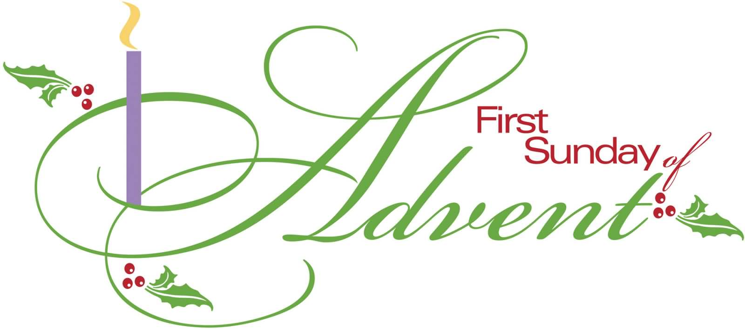

1000 Leighton Avenue at Tenth Street
Anniston, Alabama
Phone: 256-236-4457
www.graceanniston.org

“Growing together in the likeness of Christ”

